
MATHS METHODS 3 & 4
TRIAL EXAMINATION 1
SOLUTIONS
2017

Question 1 (4 marks)

- 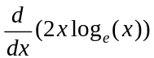
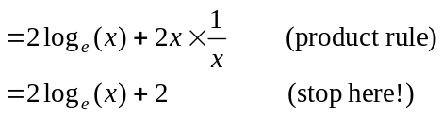
(1 mark)

- 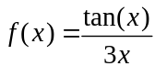
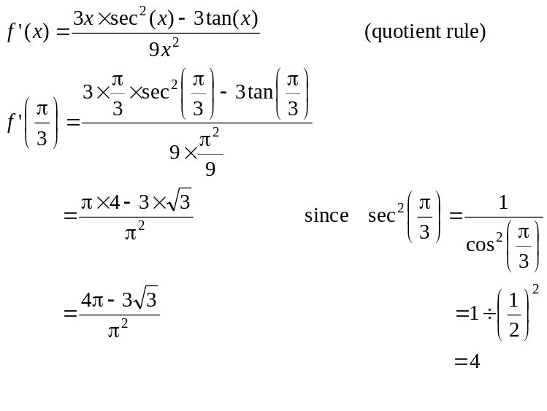
(1 mark)
(1 mark)
(1 mark)

Question 2 (3 marks)
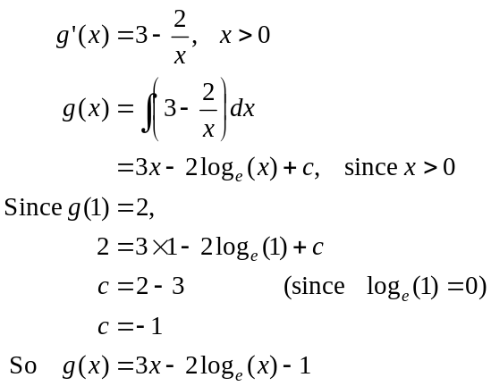
(1 mark)
(1 mark)
(1 mark)
Question 3 (4 marks)
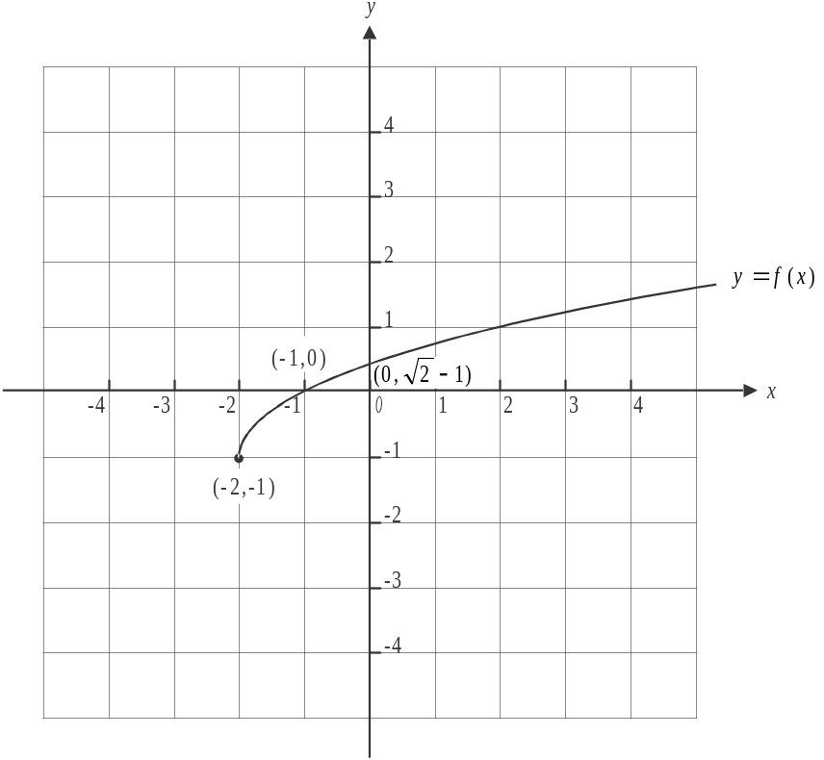

The graph of f is obtained by translating the graph of 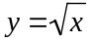 two units left and one unit down. The endpoint is therefore located at 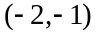.
x-intercept occurs when 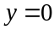
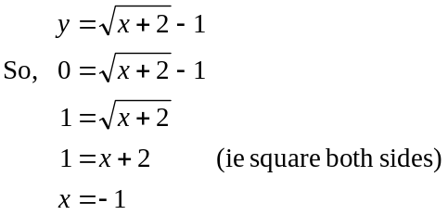
x-intercept occurs at 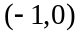
y-intercept occurs when
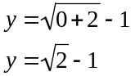
y-intercept occurs at 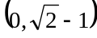
(1 mark) – correct endpoint (1 mark) – correct intercepts (1 mark) – correct shape

- 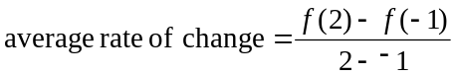
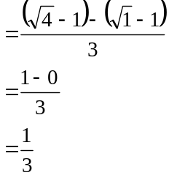
(1 mark)
Question 4 (3 marks)
- Let X represent the number of girls selected in a week.
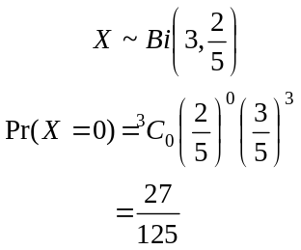
(1 mark)
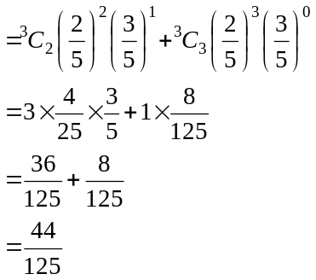
(1 mark)
- We have a binomial distribution, so 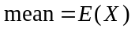
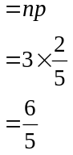
(1 mark)
Question 5 (4 marks)

- Draw a diagram.
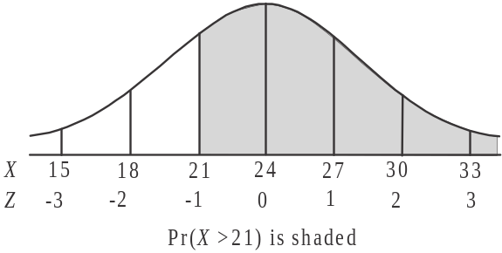
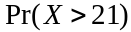 is shaded.
Since 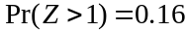,
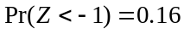
because of the symmetry of
the normal curve.
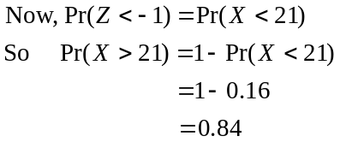
(1 mark)
b. Again, draw a diagram.
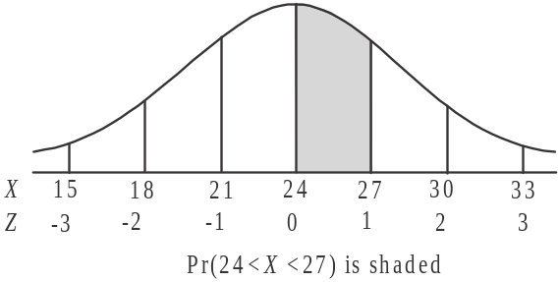
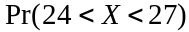 is shaded.
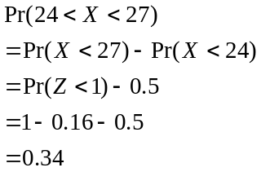

(1 mark)
c. 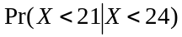
(1 mark)
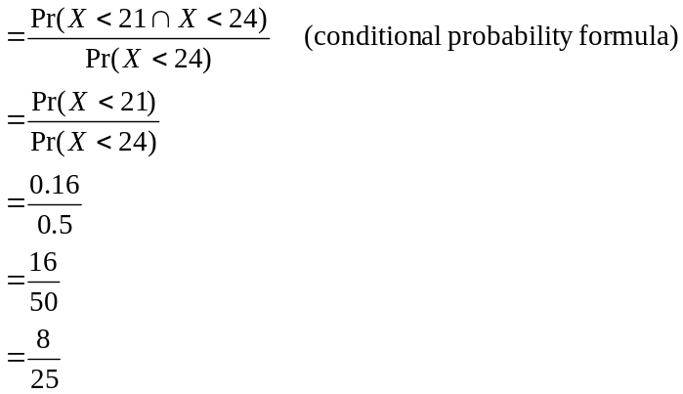
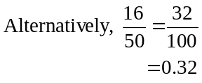
(1 mark)

Question 6 (5 marks)

- 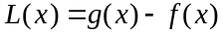
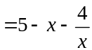
(1 mark)
- 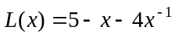
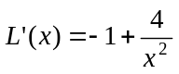
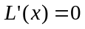 for max/min.
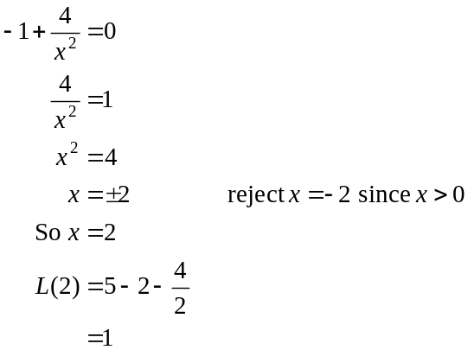
(1 mark)
Maximum length is 1 unit.
(1 mark)
- 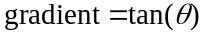
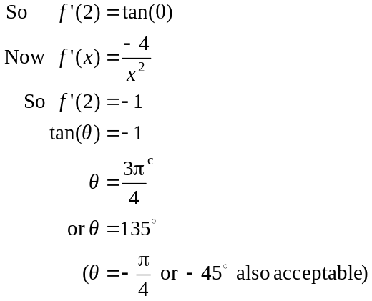

(1 mark)
(1 mark)
Question 7 (5 marks)

- The area required is shaded in the diagram below.
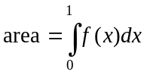
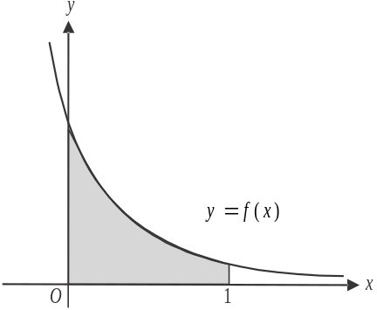
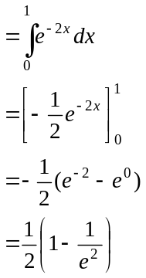
(1 mark)
(1 mark)
- 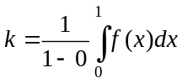
(using the average value formula which you must memorise because it isn’t on the formula sheet)

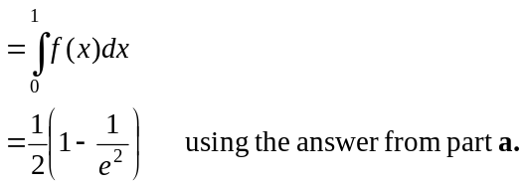
(1 mark)
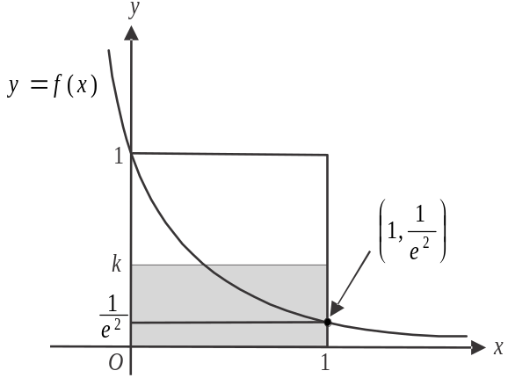

The area of the shaded rectangle (shown above) gives the average value of f between
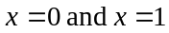.
This rectangle has a height of k units and a width of 1 unit. (1 mark)

The larger rectangle with top left corner point at 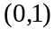 and bottom left corner at the origin has an area of 1 square unit.
The smaller rectangle with top left corner point at 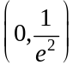 and bottom left corner at the origin has an area of 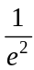 square units.
Since all three rectangles have a width of one, then 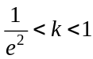. (1 mark)
Question 8 (4 marks)

- 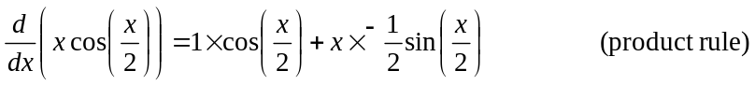
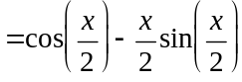
(1 mark)

- 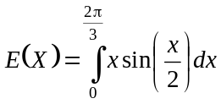. (1 mark)
From part a., we have
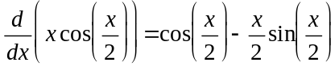

Rearranging this gives,
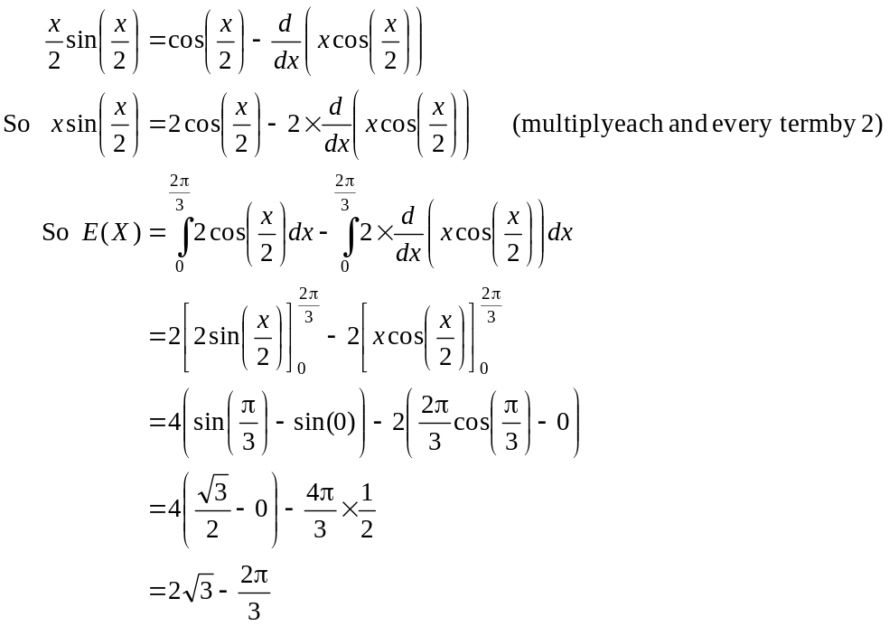
(1 mark)
(ie the antiderivative “undoes” the derivative)
(1 mark)

Question 9 (8 marks)
- Stationary points occur when 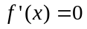
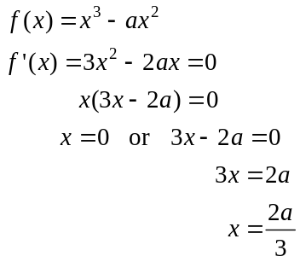
(remember a is a constant)
(1 mark) correct x coordinates
(1 mark)
Now, 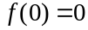, so one stationary point occurs at 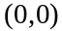.
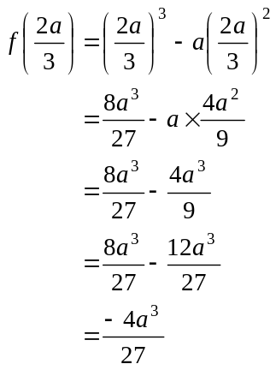
The other stationary point occurs at 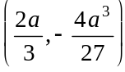. (1 mark)
- Look at the graph.
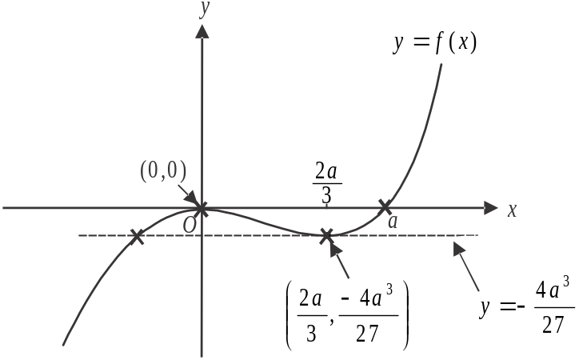

The equation 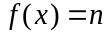 has two solutions when the graph of 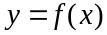 intersects with the graph of twice. Note that the graph of is a horizontal straight line.
The graph of intersects with the graph of 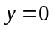 (which is of course is the x-axis) just twice. So one of the values of n is zero.
The graph of also intersects with the graph of twice when
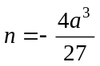 (using part a.).
So 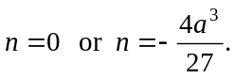 (1 mark)
- Method 1
Point U lies between the two stationary points and occurs when 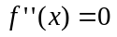. Point U is a point of inflection. (1 mark)
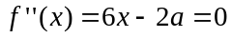
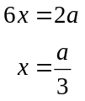
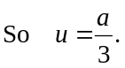 (1 mark)

Method 2
Gradient of tangent given by 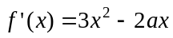 (from part a.).
Let the gradient of f at the point U be m.
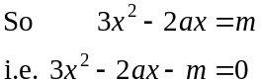
We want one solution to this equation. This is a quadratic equation in the variable x so one solution occurs when
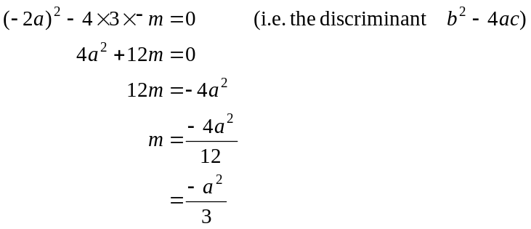
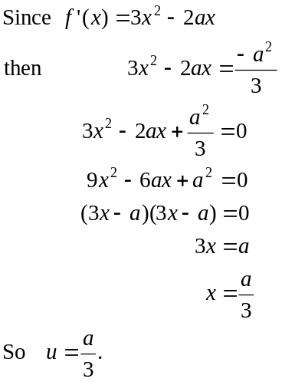
So the gradient of the tangent is 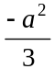.
(1 mark)

(1 mark)

- from part a.
At 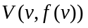, the gradient of the tangent is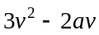.
At 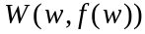, the gradient of the tangent is 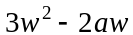.
We are told that the tangents at V and W have the same gradient so
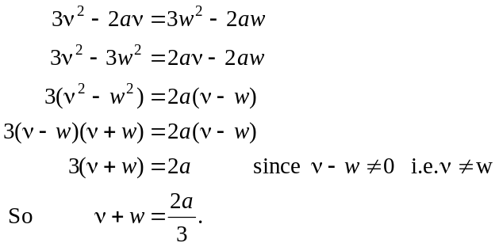
(1 mark)
(1 mark)

